**Site-Specific Environmental Emergency Response Plan Template (with tanks)**

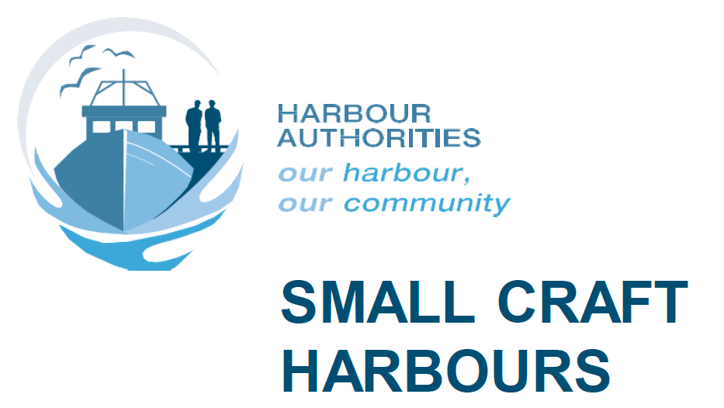

**[Insert Harbour name and civic address here]**

**[Insert date of creation here]**

**Summary**

Small Craft Harbours (SCH) are a vital part of the economic well-being of many coastal communities across Canada. Due to their proximity to sensitive ecosystems, special care must be given to managing hazardous materials (HAZMATs) at these locations. This includes proper management of petroleum storage systems including fuel dispensing and used oil storage as well as other HAZMAT storage facilities. The purpose of this site-specific Environmental Emergency Response Plan (EERP) is to eliminate, reduce and/or mitigate the health, safety and environmental impact of an uncontrolled, unplanned or accidental release of contamination into the environment. The five elements of the approach used in this EERP are prevention, preparedness, response, recovery and reporting:

**1. Prevention** – actions taken to reduce or eliminate the probability of an environmental emergency associated with the used oil storage tank system at the harbour occurring.

**2. Preparedness** – measures taken before an emergency to ensure an effective response.

**3. Response** – actions taken to respond to an actual emergency. These actions are aimed at providing a controlled, effective and timely response.

**4. Recovery** – actions taken to recover from an emergency that could be short-term or long-term activities. The aim is to return all systems and harbour activities to normal operation.

**5. Reporting** – protocols for notifying the appropriate agencies and the public, as required.

This document serves as a template to help guide Harbour Authorities (HAs) in developing a site-specific environmental emergency response plan. It is intended to be easy to understand and manage. It also serves as a guide to help HAs comply with existing emergency response and spill reporting regulations that apply to harbour operations. For further questions, please contact your local SCH manager. Be sure to keep this document up-to-date, including tank and hazardous waste information, and to keep it close to installations presenting a potential for environmental emergencies.

**How to**

**This template is made to be easily fillable and user-friendly. The following instructions explain how to fill it out:**

* **Text in black stays in the document; it forms the core of this document and is important for writing the EERP.**
* **Instructions are in red. They explain how to complete the document. They are to be erased once the site-specific EERP is written (including this “How to” section).**
* **Examples are in blue. These texts can be used for inspiration for writing your own texts. They are to be erased once the document has been written.**
* **For further questions, please contact your local SCH manager.**

Table of Contents

1. Site description 5

1.1 Location and site description 5

1.2 Site contact information 5

2. Pre-Emergency Planning 6

2.1 Potential environmental emergencies 6

2.2 Environmental aspects related to environmental emergencies 7

2.2.1 Storage tanks (petroleum products or used oil) 7

2.2.2 Other hazardous materials 8

3. Prevention 9

3.1 Maintenance and operating procedures 9

3.2 Training requirements 10

4. Preparedness 10

4.1 Health and safety 11

4.2 Spill kits and PPE 11

5. Emergency response 12

5.1 Emergency response – fuel or used oil 14

5.1.1 Fuel or used oil spills migrating from land into water 17

5.2 Emergency response – Other HAZMATs 17

5.3 Public notification 17

6. Incident recovery 18

7. Reporting 19

8. Post-emergency procedures 19

9. Roles and responsibilities 20

Appendix A: Site plan 22

Appendix B: SDSs 23

**List of Abbreviations**

**EERP –** Environmental Emergency Response Plan

**HA** – Harbour Authority

**HAZMAT** – Hazardous material

**SDS** – Safety Data Sheet

**PPE** – Personal Protective Equipment

**SCH** –Small Craft Harbours

**WHMIS** – Workplace Hazardous Materials Information System

# Site description

The following sections characterize the harbour setting and environment, providing a snapshot of the harbour’s current physical conditions. The information set out below serves as an executive summary of all the site-specific aspects and is invaluable to the Harbour Authority (HA) by providing important information at their fingertips, such as distance to the closest town and site access.

## Location and site description

SCH harbours are located in a variety of coastal settings that are all considered to be environmentally sensitive areas due to the proximity of surface water bodies (i.e. fish habitat) and because of the commercial activities which normally occur at these sites. These water bodies, such as lakes, rivers or others, are considered environmental receptors since spilled material typically flows into these and can remain in those receptors. This can be harmful since the environmental receptors are home to a host of different species ranging from planktonic organisms that comprise the base of the marine food web (and are essential for healthy fish stocks) to large marine mammals.

***(Insert Harbor name)*** is located at ***(Insert harbour address and site description, such as geographic information, relative location, GPS coordinate, environmental receptors adjacent to the site and directions on how to access the site. Other relevant information in the event of an emergency can be added as well, such as buildings, storage tanks, spill kits and storm drains location)***

***Here is an example of the previous paragraph :***

Advocate SCH is located at Highway 209, Advocate Wharf, in Cumberland County, Nova Scotia. Advocate SCH is located in Advocate Harbour on the east side of Advocate Bay (Bay of Fundy) at the mouth of Burke Brook, near the entrance to the Minas Channel. Entrance to the harbour can be located on the south side of the highway 209 and the storage tank is located at the entrance near the parking lot. The GPS coordinates for the harbour are 45.346318, -64.804751.

## 1.2 Site contact information

In case of emergency, a list of important contacts is provided in the table below.

***This table is to be filled in with information about the main contacts for all employees/users. Please update this table whenever there are any changes and make sure all harbour users have access to this list.***

|  |  |
| --- | --- |
| **Emergency Contacts** | **Telephone Number** |
| **Local Emergency Services** | |
| **Fire** | 911 |
| **Ambulance** | 911 |
| **Police** | 911 |
| **Harbour Authority EERP Coordinator** | |
| **Primary Contact** | X-XXX-XXX-XXXX |
| (Harbour Authority President) **Put in contact information** |
| **Secondary Contact** | X-XXX-XXX-XXXX |
| (Harbour Manager) **Put in contact information** |
| **Government** | |
| **SCH (Please specify region)** | X-XXX-XXX-XXXX |
| **SCH (Local Office)** | X-XXX-XXX-XXXX |
| **Put in contact information** |
| **Environment and Climate Change Canada Inquiry Line** | X-XXX-XXX-XXXX |
| **Local Contractors (For sites with fuel tank only)** | |
| **Fuel Supplier**  **Put in contact information** | X-XXX-XXX-XXXX |
| **Licensed Petroleum Contractor** | X-XXX-XXX-XXXX |
| **Put in contact information (If applicable)** |

# 

# Pre-Emergency planning

This section gives an overview of environmental aspects as well as potential environmental emergencies that can occur. This information is important for the development of the EERP because planning will be based on these potential emergencies. Note that, by law, all sites that have a regulated storage tank system or regulated substances at or above specified threshold quantities as per the *Canadian Environmental Protection Act, 1999* are required to have an EERP for that location. This EERP should be tested on an annual basis (either in the field or as a tabletop exercise) to ensure that procedures, roles and responsibilities are well understood by response personnel. The testing is also to be documented for future reference. The EERP also needs to be on-site and available close to the installations where environmental emergencies are most likely to occur. Awareness training should also be done to make sure every user of these type of system is conscious of the content of the EERP.

## Potential environmental emergencies

Since we know that an environmental emergency at the site consists of a spill with a medium to high risk, it is important to know what substance can be spilled on site and can create this type of event. Here is a short list of substances:

Petroleum hydrocarbon products

Chemical and fuel gases

Acids

Solvents

Bleach

Other

Knowing these substances, it is important to be aware of their presence and which activities can lead to an accidental spill. The following incidents/activities on site could lead to an environmental emergency of the above-mentioned substances:

Pipe system or mechanical failure

Container rupture/puncture

Fuel-dispensing

Fire

Overflow during filling or emptying of portable containers

Construction and maintenance practices

Accidental release

Other

All of the above-mentioned release scenarios are of environmental concern and are to be considered important according to this EERP.

## Environmental aspects related to environmental emergencies

Due to the locations of SCHs in different types of environments and the numerous activities that occur on-site, many environmental aspects can be affiliated with these sites. These aspects involve direct interaction between activities and the environmental receptors. This section serves as an overview of these aspects. It also defines them and pinpoints installations that are related to these aspects.

### Storage tanks (petroleum products or used oil)

Used oil is a combustible and toxic liquid. It is rated as a moderate health hazard, a moderate flammability hazard and an insignificant reactivity hazard. It can be ignited by heat, sparks or flames. Like oil, fuel is a combustible and toxic material. Typically highly flammable, fuels such as gasoline, furnace oil or diesel, can cause certain health effects when people are exposed to it, such as headaches, nausea and rashes. Because of its high volatility, fuel can contribute to air pollution when spilled into the environment. Due to their physical and chemical properties, these hazardous materials can have major impacts on aquatic environments, such as the destruction of certain aquatic plants, disruption in food resources for certain animal species and even reproductive problems for some other species.

Due to the possibility of spills, it is important for users to be conscious of the presence of these tanks and to be aware of their surroundings. It is also important for the person installing or decommissioning these types of installations to have the proper approvals and to have stamped as-built drawings available. Leak detections should also be properly met to make sure no unwanted contamination is created. Also, for storage tanks, remember to allow a 10% air space when filling, to allow for the expansion of liquids in warmer temperatures. The table below gives an overview of storage tanks on site and their registration information. Remember to keep this information up-to-date. ***(If there are no storage tanks on site, please put N/A.)***

|  |  |  |  |  |  |  |
| --- | --- | --- | --- | --- | --- | --- |
| **System #s** | **Environment and Climate Change Canada registration number (if applicable)** | **System Characteristics** | **Product \*** | **Tank Volume L** | **Location, Type & Spill Containment Features** | **Surrounding Area Description (include site-specific environmental receptors)** |
|  |  |  |  |  |  |  |
|  |  |  |  |  |  |  |
|  |  |  |  |  |  |  |

* An safety data sheet (SDS) for these products can be found in Appendix B. This will provide important information concerning the product, such as proper storage and handling, first aid, proper personal protective equipment (PPE), compatibility with other products, flammability, etc.

**For every product on site, an SDS should be included in this EERP. This is to ensure information about proper first aid response and spill response for the product is readily available in an emergency including required PPE. These sheets are to be added in the appendix section (Appendix B). Used oil and fuel SDSs can be found on the SCH website in the Tools for harbour authorities section.**

### Other hazardous materials

Hazardous materials (HAZMATs), such as paints, glycol and solvents, are used for numerous activities on site. These materials present a danger, not only to the environment but also to the health of users because of the potential for spills. These spills can cause different impacts, such as the possibility of dangerous reactions, corrosion of different materials and the creation of contaminated sites. The table below is intended to provide an overview of the storage locations of these HAZMATs and the surrounding area. ***(If there is no HAZMAT storage installation on site, please put N/A.)***

|  |  |  |  |
| --- | --- | --- | --- |
| **HAZMAT Storage Location** | **Product(s) \*** | **Quantity (average)** | **Surrounding Area (if storage exterior to a building) (include site specific environmental receptors)** |
|  |  |  |  |
|  |  |  |  |
|  |  |  |  |
|  |  |  |  |

* An SDS for these products (only those that are usually used on-site) can be found in Appendix B.

**Just like for fuel and used oil, SDSs are to be added as an appendix (Appendix B) to this EERP for HAZMATs that are frequently used on-site.**

# Prevention

An ounce of prevention is worth a pound of the cure. This applies not only to our health but also to the environment. That is why it is important to keep good maintenance and operating procedures for installations that present environmental emergency risks and to train users in reducing these environmental emergency risk factors. This includes having proper operational and spill response signage to make sure users have the proper information at hand.

### 3.1 Maintenance and operating procedures

Incorrect or inefficient maintenance and operation of on‐site equipment can increase the risk of the occurrence of an environmental emergency, especially petroleum products and allied petroleum product equipment.

In order to ensure that the risk is minimized, the following measures should be followed by all on‐site personnel:

* The HA maintains a preventive maintenance program for equipment to prevent environmental emergencies;
* All on‐site equipment must be properly maintained and inspected and only used when in good working condition;
* All equipment maintenance must be performed in designated areas equipped with the appropriate spill response equipment (this will be developed in later sections of this EERP);
* All on‐site equipment must be operated only according to the manufacturer’s specifications;
* When equipment is parked or being stored, a drip pan must be placed such that it catches all potential leaks (if applicable);
* All maintenance materials stored on site must be stored in compliance with applicable legislation;
* All material storage containers must be labelled in compliance with the Workplace Hazardous Materials Information System (WHMIS) guidelines;
* SDSs must be kept up to date and posted in accordance with WHMIS;
* Materials should only be stored with compatible materials;
* All petroleum, oil and lubricant products must be stored in an identified location (designated area in accordance with regulations and codes);
* All drum-type storage must be placed on appropriate spill containment platforms; and
* All systems should be installed by certified professionals.

### 3.2 Training requirements

***Many types of training can be offered on various environmental issues. This can include WHMIS and transportation of dangerous goods. Since these types of training differ from one region to another, contact your local SCH manager to find out what training is required, what training is recommended*** ***and how to document this training. After discussion with the manager, a short text has to be completed to describe this training. Here is an example:***

Training associated with this EERP will consist primarily of review and general familiarization with the EERP (awareness training), the site-level environmental management plan (especially for environmental best management practices), the emergency contact list and the location and usage of on-site PPE and resources.

The EERP Coordinator (HA president) will ensure that all site personnel and contractors involved in the operation, inspection or maintenance of the storage tank system and HAZMAT storage location, and all contractors retained by the HA are familiar with the location and use of the on-site PPE and resources.

It is assumed that external emergency responders (e.g. local fire departments) are suitably trained in such emergency response. The EERP Coordinator will ensure that a copy of the site-specific EERP is provided to the local fire department for its information.

The training program should be revised and updated as amendments are made to the EERP.

# Preparedness

When the prevention of an environmental emergency fails, it is important to be prepared to respond appropriately. Remember that preparedness begins with having the EERP readily available and close to installations with a high risk of an environmental emergency. It is also important to have proper signage near these installations and to review them to make sure they present the proper information. Finally, it is important to be aware of your surrounding, especially when it comes to knowing the location of environmental receptors nearby so that the spill does not flow into them.

## 4.1 Health and safety

The first step in any response procedure is to evaluate the danger to human health. If there is no immediate danger, the responding personnel can begin to address the environmental emergency. However, if imminent danger is detected, personnel must be prepared to act to protect human life, such as using the proper equipment or even evacuating the area. It is therefore important to carefully follow the steps in section 3.3.1 to assess who responds to the emergency and to use the proper PPE (described in section 3.2.2) for the situation. Be sure to refer to the respective SDS as they describe risks associated with products (as seen in Appendix B).

## 4.2 Spill kits and PPE

Spill kits and PPE should be placed at all locations where the potential for a spill exists, such as areas with storage tanks or hazardous materials. The spill kits should be labelled so that they can be easily identified; the labels need to be legible and clearly visible. The location of spill kits can be found on the site plan (as seen in Appendix A).

Each environmentally sensitive area should have a spill kit that contains appropriate material to clean up the hazardous product. Each spill kit should contain a list of contents to identify the specific materials for that particular spill kit; this will also help with spill kit inspections. These spill kits should be specific to the material that poses a threat of an environmental emergency. It is recommended that a quick-release tab be used to indicate when the spill kits have been opened. Refer to SDS for specific safety concerns (Appendix B). In addition, the site must be equipped with first-aid supplies, such as eye wash stations and first-aid kits, as well as proper fire extinguishers.

It is also important to have certain PPE on site for different kinds of spills. Examples of PPE include:

* Eye protection: safety glasses, chemical splash goggles
* Skin protection: resistant gloves, nitrile rubber, clothing

Refer to SDS for specific PPE requirements (Appendix B).

PPE must be worn by those responding to the release/spill as required. Based on the variety of substances and potential incident scenarios, be sure that the correct response equipment and PPE are located on-site, in an easily accessible location, adjacent to areas where the potential for an incident is high and that staff who may potentially respond to incidents be familiar with PPE use. PPE equipment can often be found in spill kits located near storage tanks and hazardous materials.

Each area where there are fuel storage tanks or other environmental hazards should be assessed annually to ensure that the associated spill kit is appropriate (contains the materials to clean up the hazardous product) and is located adjacent to the high‐risk area.

Here is a list for every spill kit on site:

**It is important to have spill kits that are prepared for specific responses to the environmental emergencies that can occur. That is why a list should be developed and placed in this section of the EERP for every kind of spill kit for every potential environmental emergency. Here is an example:**

**Fuel PPE spill kit**

|  |  |
| --- | --- |
| **Quantity** | **Item** |
| 1 | 95-gallon (205-litre) overpack plastic drum with screw top |
| 2 | Safety glasses/goggles |
| 1 Package | Large nitrile gloves |
| 10 | Clear disposable 50–60 gallon bags and ties |
| 1 roll | Yellow caution tape |
| 2 | 20–25 lb bags of absorbent granular material |
| 150 | 17” x 19” oil-only absorbent pads (white) |
| 12 | 3” x 4’ oil absorbent socks |
| 6 | 3” x 8’ oil absorbent socks |
| 2 | 5” x 20’ oil absorbent socks |
| 2 | Single-use epoxy plugging for oil tanks (example: 2 sticks or 2 single-use tubes or 2 small tubs) |
| 1 | Folding/collapsible shovel |
| 2 | Orange traffic cones |
| 1 | (90–100 cm2) Neoprene drain cover |
| 1 | Instruction sheet for how to clean up an oil spill affixed to the underside of the screw top (English and French). Contents of the kit also to be listed in English and French |

# 5. Emergency response

In the event of an environmental emergency, on-site users will need to determine the level of response required. Contact the EERP coordinator, who will assume the roles and responsibilities during an emergency.

When an environmental emergency occurs, it is important to start by assessing the situation. First, identify the product(s) involved, verify the nature of the hazard using SDSs and implement any applicable safety procedures (this includes evacuating the area if necessary). Second, cut off or isolate the source of the hazard, if possible, and if safe to do so, and if you have the appropriate training. Never enter the affected area alone – obtain the assistance of other qualified personnel and contact the EERP Coordinator, who is to use their discretion in determining any further course of action.

The second step is to determine the level of response required since some emergencies are more dangerous than others. The flowchart below gives an overview of the response levels and decision criteria.



**Level 1:** If trained, clean up the spill.

**Level 2:** Qualified internal response team on site would respond to the spill (applicable

to sites with an internal response team). The qualified person during after-hours or on the weekend would be the person on standby.

**Level 3:** The spill cannot be stopped and controlled safely. Call for outside assistance (i.e. fire department).

All levels should notify authorities, as required. If a spill could adversely affect or endanger the public, site personnel will coordinate with the local fire and police departments to implement isolation and evacuation zones.

Do not take action if there is imminent danger; wait for emergency responders to arrive. Follow these steps to try and control the spill:

* If possible, approach the spill site with the wind at your back.
* Stop operations related to the release of the product and shut off the installation (if possible).
* Safely contain and control the spill as soon as possible using appropriate equipment only if the situation is deemed safe to do so (e.g. eliminate source of leak/spill – i.e. turn off values or taps, etc.).
* Cover drains/sewers/oil-water separators (If safe to do so).

If a release to the atmosphere occurs (e.g. leaking compressed gas cylinder, ozone-depleting substance release from air conditioning system, asbestos release, a natural gas leak), take the following steps:

* Assess the material involved (always refer to the SDS for further questions).
* If safe to do so, shut off the source of the leak, contain the material or move the leaking material outdoors.
* If unsafe, evacuate the area and call for outside assistance.

## 5.1 Emergency response – fuel or used oil

Here are the steps to take during a **fuel or used oil spill:**

|  |  |  |
| --- | --- | --- |
| **Emergency Response – Petroleum products or Used Oil Spill** | | |
| **Step** | **Action** | **Responsible Party** |
| 1 | Determine if there is a threat to human health or safety (i.e. explosive vapours or fire hazards). If there is a threat, evacuate and isolate the area. | Spill identifier (all) |
| 2 | If there is a threat to human health or safety, evacuate and isolate the area. |
| 3 | Contact: i) EERP Coordinator: **XXX-XXX-XXXX (insert phone number) (primary contact)** or **XXX-XXX-XXXX (insert phone number)** **(secondary contact)**  ii) Regional Spill Reporting Centre: **XXX-XXX-XXXX (insert phone number)** |
| 4 | Eliminate potential hazards (i.e. explosive vapours or fire hazards), as required. | Those trained in oil spill response |
| 5 | Take immediate action to contain the spill or stop the spill at source. Use an oil boom from the spill kit and oil absorbent pads to soak up the surface pollutants. **NEVER EXPOSE YOURSELF TO DANGER**. |
| 6 | Prevent spilled product from entering drains, ditches and environmental receptors. |
| 7 | Report the spill immediately to the Regional Spill Response Centre by referring to the section on **INCIDENT RECOVERY**. |
| 8 | Follow any instructions given by the Regional Spill Response Centre. |
| 9 | Contact local emergency services, as required. |
| 10 | Record all events immediately, complete applicable incident report and forward a copy to SCH and the appropriate authorities. | EERP Coordinator |
| 11 | Ensure that spill containment materials are disposed of according to applicable regulations. |
| 12 | Coordinate further environmental site assessment/remediation, as required. |

The images below illustrate how to contain a spill of fuel and/or used oil (petroleum-based products).

**Petroleum products or used oil spill on land**

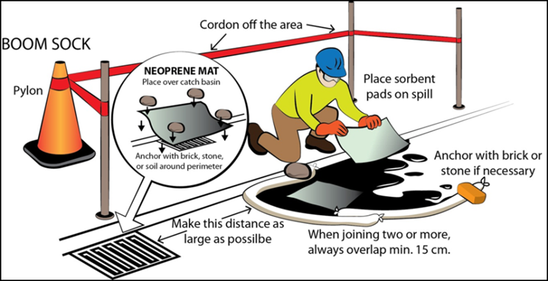

**Petroleum product or used oil spill in a ditch or low-flow narrow watercourse**

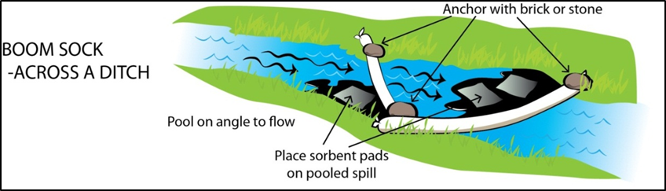

### 5.1.1 Fuel or used oil spills migrating from land into water

When a petroleum product release has the potential to migrate from land to water (i.e. land to ocean, stream, lake, pond), the most appropriate response will be to estimate the dimensions, the rate of water flow and the morphology of the banks.

Avoid directing liquid release/spill towards the drainage system. Possible responses are:

* Build retaining dikes
* Use natural topography or a ditch
* Dig a trench
* Install floating barriers made of sorbents and/or absorbent socks
* Install booms (logs and planks, drum, etc.)
* Install plywood sheets at culverts

## 5.2 Emergency response – Other HAZMATs

As shown in section 2, environmental emergencies can be caused by spills of other HAZMATs, such as solvents, acids or bleach. Since numerous HAZMATs can be present on-site, it is important to have an SDS (Appendix B) for every one of them that are regularly used on site. Therefore, when responding to a spill other than from oil or fuel, the spill section in the SDS of the spilled HAZMAT will serve as a guide on how to respond. It is important to follow the specific spill response for the specific HAZMAT since they can have different health effects and have different responses from one another.

## 5.3 Public notification

Generally, public notification would not be required in the event of a spill or a fire at the harbour due to the low probability of impacts on the public. However, after an initial assessment of an incident and determination of the appropriate course of action, the Harbour Authority, or professional responders such as the police or fire department, may determine that there is a need to notify the public, immediately evacuate the occupants of adjacent buildings and/or remove nearby vessels. Here are the steps to take in such a situation:

* Notify the federal and provincial/territorial authorities in order to coordinate appropriate oversight of the response (see contact information in section 1.2).
* In turn, these authorities will inform Environment Canada of the notifications.

Notifications of environmental emergencies or occurrences and the transfer of information to the appropriate authorities are essential for timely and effective oversight of the response, as may be warranted.

# 6. Incident recovery

Spills of hazardous materials or hazardous waste such as fuel, waste oil, paints and solvents, are considered small-scale only if they can be controlled, absorbed and cleaned up using equipment available on site such as spill response kits. For larger spills, professional spill recovery services will be required.

All spills that result in a release into the environment must be immediately reported to the Regional Spill Response Centre. After a fire or product release incident has occurred on the site, various measures may be required:

* It may be necessary to complete subsurface investigations and/or remediation of impacted soil, groundwater or surface water in the vicinity of the storage tank system.
* If necessary, the removal and disposal of petroleum hydrocarbon–impacted soil, groundwater or surface water or spilled petroleum products must be carried out in accordance with existing environmental regulations.
* The storage tank system must be fully inspected, with any damaged components repaired or replaced before the system is put back into service. Depending on the extent of the damage, particularly if the product release emergency was also associated with a fire emergency, it may be necessary to remove the petroleum products from the storage tank system and replace the entire system.
* A temporary storage tank system may be required for the site until the damaged system is inspected and repaired or replaced.
* Depending on the nature and circumstances of the incident, it may be necessary to revise the storage tank system’s operations, inspection or maintenance procedures or to revise the EERP.

It is important to clean up and recover from environmental damage after an emergency. Environmental damage is the impact pollution has on the bio-physical environment. Any product spilled or released must be recovered quickly to limit its migration or spread, taking into consideration the product’s properties, weather conditions and surrounding terrain. If these contaminants are not recovered, more problems can occur, such as the creation of contaminated sites.

Once the release has been contained, recovery operations must be carried out safely and as quickly as possible. Any products spilled must be removed from the ground and water to reduce the risk of contaminant migration. The recovery operation involves picking up, cleaning and temporarily storing the spilled substance and any sorbents used (remember that any sorbents used to recover a hazardous material are considered hazardous waste).

Wastes are to be kept in a safe location designed for storage of hazardous waste. Ensure all waste is stored in such a manner as to reduce the potential for further spills and/or impact on the environment, human health and safety. Clean-up materials and storage bags can be found in the spill kits.

Finally, make sure the contaminated material is properly disposed of by certified professionals. Also, these disposals should be documented and kept for a minimum of 5 years.

# 7. Reporting

In the event of a release of petroleum products of over 100 L, a telephone notification must be followed by a written report to Environment Canada. For environmental emergencies from storage tanks, the requirements for the written report are outlined in section 41 of the *Storage Tank Systems for Petroleum and Allied Petroleum Products Regulations*. For other types of environmental emergencies, the Environmental Emergency Regulations will be followed. It is important to note that this kind of report will be written by DFO/SCH, but the HA’s help will be needed to complete it.

In addition, after an environmental emergency, DFO/SCH is responsible for completing an Environmental Incident Report (EIR). This report will provide an overview of the environmental emergency so that everyone involved can have a better picture of how the event happened. This will also help to prevent future environmental emergencies.

# 8. Post-emergency procedures

After everything is over, it is important to learn from past mistakes and make sure that these kinds of events do not happen again. The steps below show how to properly respond post-emergency :

* Review/debrief
* Upon completion of spill clean-up activities, review the overall effectiveness of response activities. Specifically review:
  + - The adequacy and appropriateness of this EERP
    - The adequacy and availability of spill kits
    - Emergency contact numbers
    - Program gaps
    - Lessons learned
* Update the Response Plan
* Upon completion of the post-spill review/debrief, update the EERP to address any gaps or deficiencies (as required). Replace existing copies of the EERP on-site with the updated version
* Clean response equipment
* Ensure all response equipment has been cleaned thoroughly after a spill is cleaned up. Any equipment/supplies that cannot be cleaned are to be disposed of with the contaminated waste from the spill

Ensure spill kits used during a spill are replenished prior to putting the spill kits away.

# 9. Roles and Responsibilities

Harbour properties are federally owned, and a lease defines the relationship between SCH and individual Harbour Authorities. Although dailyadministration and operationof most SCH harbours have been delegated to HAs, SCH retains the overall responsibility for environmental stewardship.

SCH recognizes and respects each Harbour Authority as a separate legal entity with the freedom and independence to make its own decisions and take responsibility for its actions. SCH permits Harbour Authorities to seek business opportunities to further their interests, such as the ownership of petroleum storage tank systems. Such permission is subject to compliance with all federal, provincial and municipal laws, codes and by-laws.

Key personnel/groups involved in implementing this EERP include:

* The Harbour Authority Board of Directors
* EERP Coordinator (Harbour Authority President)
* Personnel who operate, inspect and maintain the storage tank system
* Local emergency responders (i.e. fire department, local contractors)

The roles and responsibilities of each of these personnel/groups with respect to the implementation of the EERP are as follows:

**THE HARBOUR AUTHORITY BOARD OF DIRECTORS**

* Ensure that the EERP is kept up to date.
* Ensure that the EERP Coordinator is appointed and aware of their role and responsibilities.
* Ensure that the EERP Coordinator is trained with respect to the content and implementation of the EERP and the use of emergency response equipment.
* Review and sign off on the EERP.
* Ensure that a copy of the EERP is available at the site.
* Ensure that a copy of the contact list is posted in the vicinity of the storage systems.
* Ensure that the PPE is available and maintained at the site and close to potential environmental emergency sites.
* Ensure that a copy of the EERP is provided to the local fire department and that the updated versions are shared as well.

**EERP COORDINATOR**

* Coordinate the implementation of the EERP.
* Verify, inspects and notify the appropriate Harbour Authority Board of Directors of required spill response equipment.
* Ensure that the personnel who operate, inspect and maintain the petroleum storage tank systems are trained with respect to the content and implementation of the EERP and the use of emergency response equipment.
* Local emergency responders are contacted in the event of an emergency.

**PERSONNEL WHO OPERATES AND MAINTAIN THE STORAGE TANK AND DISPENSING SYSTEMS**

* Become familiar with and sign off on the EERP.
* Become familiar with the location and use of emergency response equipment.
* Follow the EERP if necessary.
* Contact the EERP Coordinator and the local emergency responders in the event of an emergency.
* Advise the EERP Coordinator when the on-site emergency response equipment needs replacement.
* Advise the EERP Coordinator should the EERP need to be revised (i.e. addition or change of storage systems, site infrastructure, etc.).

**LOCAL EMERGENCY RESPONDERS**

* **Local fire department** - The local fire department will respond to fire emergencies when called. The local fire department will take control of the emergency response for fires while on site.
* **Local contractors** – Local contractors will provide equipment (e.g. backhoe, loader, boat) and/or materials (e.g. sand, clean fill) to assist DFO in an environmental emergency response at the site.

# Appendix A: Site plan

***The site plan can be in many forms. The key is to be able to locate every installation on site, including storage tanks, spill kits, emergency shutoff devices, environmental receptors other than the ocean and storm drains. Here is an example:***

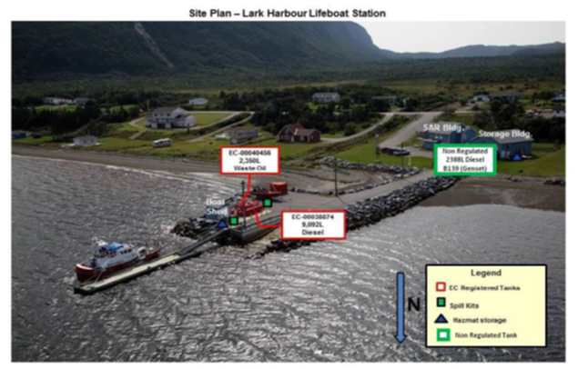

# Appendix B: SDSs

**This section is dedicated to SDSs. Please evaluate what kind of products are used on site and add the respective SDSs in this section. Used oil and fuel SDSs can be found on the SCH website (Tools for harbour authorities).**